



# Food Connect

( To supply leftover food to poor )

1. **Project Overview**

The FoodConnect project is a transformative initiative aimed at creating a robust volunteer management system within Salesforce. This project addresses the complexities and logistical challenges associated with food distribution events. The current landscape involves significant coordination between various stakeholders, including venues, drop-off points, volunteers, and the tasks that need to be completed. The objective is to develop a solution that not only improves operational efficiency but also enhances the user experience by providing seamless access to relevant data and functionalities.

Through the implementation of a comprehensive volunteer management system, we aim to:

* + Streamline the process of assigning tasks to volunteers based on their availability and proximity to venues.
  + Improve the accuracy of data related to venues and drop-off points, thereby reducing discrepancies and ensuring that all stakeholders have access to the same information.
  + Facilitate better communication among all participants in the food distribution process, ensuring that everyone is informed about their roles and responsibilities.

By addressing these challenges, the FoodConnect project aligns with the long-term goals of the organization, which include optimizing food distribution logistics and enhancing volunteer engagement. The project is expected to result in improved satisfaction among volunteers and more effective food distribution efforts.

1. **Objectives**

The objectives of the FoodConnect project can be categorized into business goals and specific outcomes:

## Business Goals:

* + - Improve Volunteer Management Efficiency: Develop a streamlined system for assigning tasks to volunteers, minimizing the time spent on coordination and maximizing volunteer engagement.
    - Enhance Data Accuracy: Implement mechanisms to ensure that data related to venues, drop-off points, and volunteers is accurate, up-to-date, and easily accessible.
    - Facilitate Better Communication: Create a system that allows for clear communication between volunteers, coordinators, and stakeholders involved in food distribution.

## Specific Outcomes:

* + - Creation of Custom Objects: Develop custom objects to manage data related to Venues, Drop-Off Points, Tasks, Volunteers, and Execution Details, ensuring that all relevant information is organized and easily retrievable.
    - Development of a User-Friendly Lightning App: Create a Lightning App that provides users with intuitive access to critical information, allowing for quick navigation between different functionalities.
    - Implementation of Sharing Rules: Establish sharing rules that manage data visibility based on distance criteria, ensuring that volunteers only see tasks and information relevant to their locations.

1. **Salesforce Key Features and Concepts Utilized**

To achieve the project objectives, the following Salesforce features and concepts have been utilized:

## Custom Objects:

* + - Venues: This object stores information about locations where food distribution activities are planned. Key fields may include Venue Name, Address, Capacity, and Contact Information.
    - Drop-Off Points: This object captures details about specific locations where food will be delivered, ensuring that volunteers know where to go for food pick-up.
    - Tasks: This object tracks specific assignments given to volunteers, including details such as Task Name, Description, Due Date, and Assigned Volunteer.
    - Volunteers: This object maintains records of all individuals participating in the program, including contact information and availability status.
    - Execution Details: This object logs the details of tasks completed by volunteers, providing a record of their contributions.

## Relationships:

* + - Master-Detail and Lookup Relationships: Establishing relationships between objects defines how data is interconnected. For example, a Task may have a Master-Detail relationship with Execution Details, indicating that each task can have multiple execution records. A Lookup relationship might exist between Volunteers and Drop-Off Points, enabling easy tracking of which volunteers are assigned to which drop-off locations.

## Flows:

* + Utilizing Salesforce Flow, we can automate the process of creating Venue records and streamline user interactions by guiding users through a series of steps to ensure all necessary information is collected.

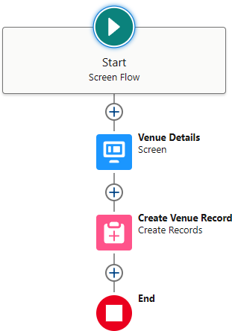

## Triggers:

* + Implementing Apex triggers allows for automated actions based on specific criteria, such as calculating distances between venues and volunteers’ locations when records are created or updated.

## Reports and Dashboards:

* + Custom reports and dashboards visualize data related to volunteer activities, tracking metrics such as the number of tasks completed, hours logged by volunteers, and food distribution statistics.

1. **Detailed Steps to Solution Design**

The following steps outline the process of designing and implementing the FoodConnect solution:

## Creating Developer Account:

* + Sign up for a Salesforce Developer account, which will serve as the testing and development environment for the project.
  + Activate the account via the verification email to gain access to Salesforce features.

## Creating Custom Objects:

* + Navigate to the Object Manager in Salesforce Setup to create the custom objects listed above. Each object will include fields tailored to capture relevant data accurately.

## Creating Custom Tabs:

* + Create custom tabs for each of the newly created objects, facilitating easy navigation for users within the Salesforce interface.

## Creating a Lightning App:

* + Use the App Manager to create a new Lightning App named "FoodConnect."
  + Add relevant navigation items (custom objects and reports) and assign user profiles to ensure that only authorized users can access specific functionalities.

## Establishing Relationships:

* + In the Object Manager, create Lookup and Master-Detail relationship fields as needed to define how data is connected. This will allow for efficient data retrieval and reporting.

## Creating Fields for Each Object:

* + For each custom object, define the necessary fields, including data types (e.g., Text, Number, Date) and attributes (e.g., Required, Unique). This ensures that all relevant information is captured.

## Creating Flows:

* + Design a screen flow for capturing Venue details that allows users to enter information seamlessly. Automate record creation to ensure that data is accurately logged.

## Creating Triggers:

* + Implement Apex triggers to automate calculations, such as determining the distance between volunteers and venues. This feature will ensure that volunteers are assigned to the closest tasks, improving efficiency.

## User Creation and Management:

* + Create user profiles for different stakeholder groups, including volunteers and administrators. Assign appropriate permissions to each profile to control access to data and functionalities.

## Report Types and Dashboards:

* + Define custom report types to track volunteer activities, and create dashboards to visualize key metrics related to food distribution and volunteer engagement.

1. **Testing and Validation**

A comprehensive testing phase ensures the system operates as intended:

* + **Unit Testing:** Conduct unit tests on Apex classes and triggers to verify their functionality and performance under various conditions.
  + **User Interface Testing:** Validate the user interface to ensure that it is intuitive and user-friendly, allowing all users to navigate and complete tasks efficiently.

1. **Key Scenarios Addressed by Salesforce in the Implementation Project**

The implementation of the FoodConnect project has effectively addressed several key scenarios:

* + **Managing Volunteer Assignments**: Volunteers can be assigned tasks based on their availability and location, optimizing the food distribution process.
  + **Tracking Food Distribution**: The system tracks food distribution through various venues and drop-off points, allowing coordinators to monitor progress and efficiency.
  + **Reporting on Volunteer Activities:** Reports generated from the system provide insights into volunteer activities, including tasks completed and feedback received, helping to improve future operations.

**Conclusion**

The FoodConnect project successfully established a comprehensive volunteer management system within Salesforce, achieving significant improvements in data management, user experience, and operational efficiency. The implementation of custom objects, relationships, and automation features has streamlined food distribution processes, enhancing the organization's ability to coordinate volunteer efforts effectively. This project lays a solid foundation for future enhancements, scalability, and the potential integration of additional features that could further optimize food distribution logistics.

As the project progresses, continued monitoring, user feedback, and iterative improvements will be essential to ensure the system remains aligned with the evolving needs of the organization and its volunteers.

**venues**

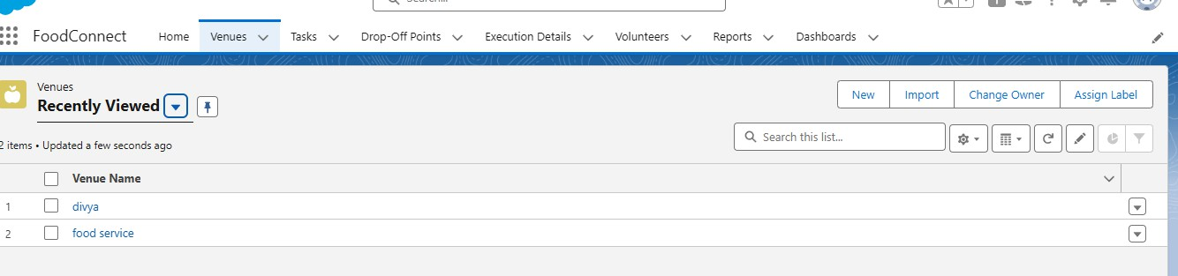

**Tasks**

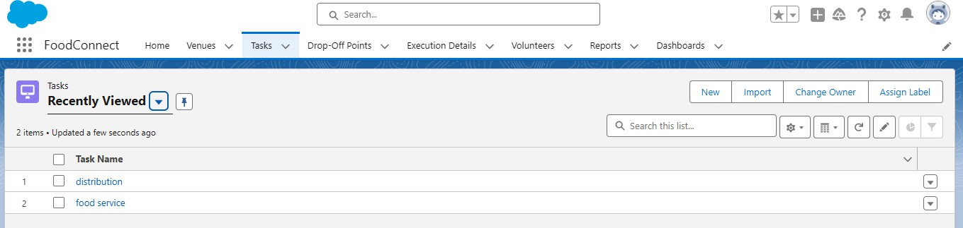

**Drop-off point**

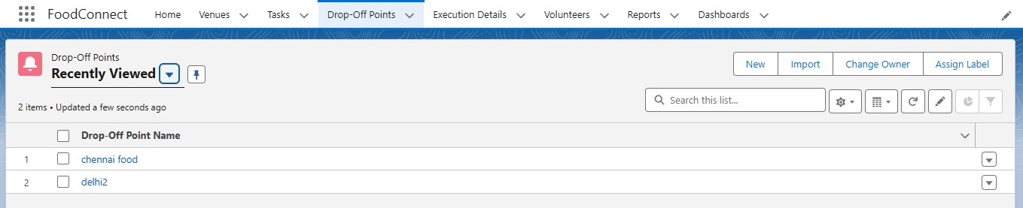

**Volunteers**

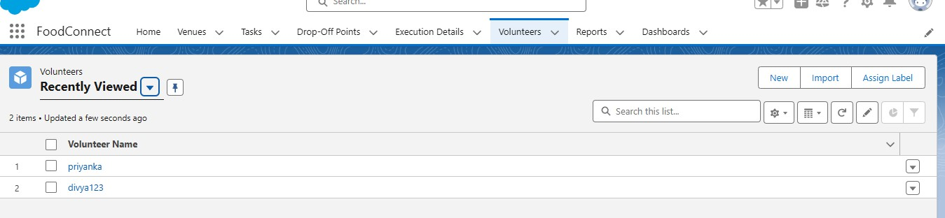

**Reports**

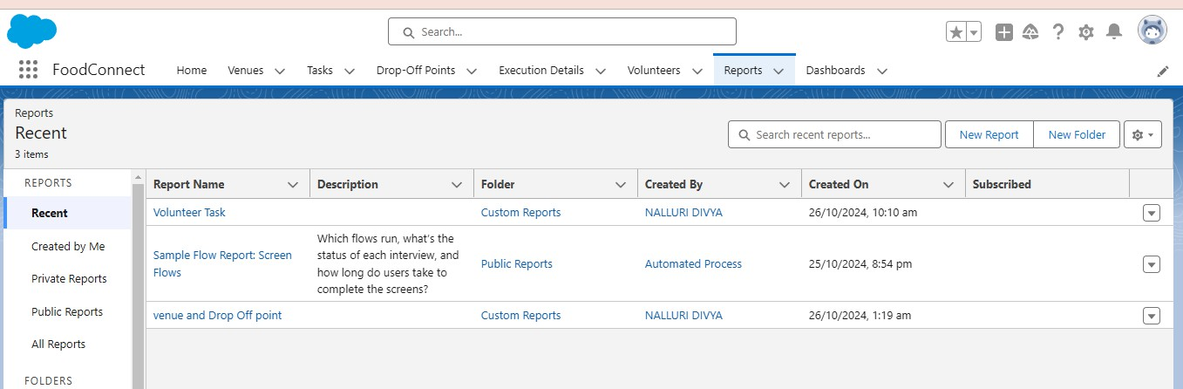

**Dashboard**

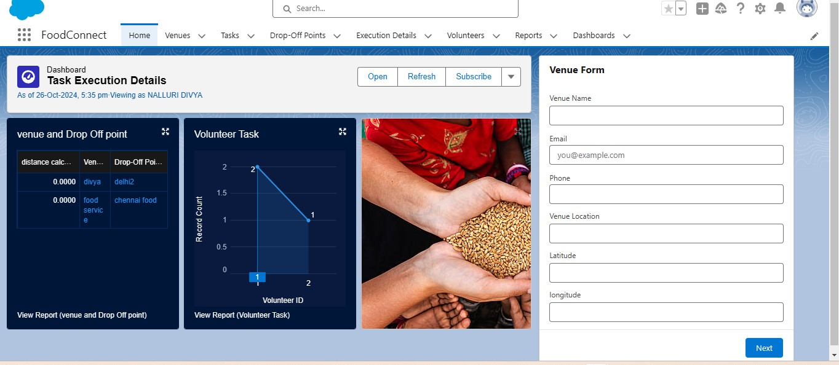

# Nalluri Divya

**Vishnu institute of technology**